[**www.shahandanchor.com**](http://www.shahandanchor.com/) **Tel: 022 2558 0854**



**Mahavir Education Trust’s**

SHAH & ANCHOR KUTCHHI ENGINEERING COLLEGE

**Mahavir Education Trust Chowk, W.T. Patil Marg, Chembur, Mumbai 400 088**

Affiliated to University of Mumbai, Approved by D.T.E. & A.I.C.T.E.

Awarded provisional accreditation for Computer & Electronics Engineering by NBA

(for 2 years from 06-08-2014)

|  |
| --- |
|  |

**Certificate**

|  |  |  |
| --- | --- | --- |
| This is to certify that |  |  |
| **Name of the Student** | **Division** | **RollNo** |
| Ansh Ved | TE-5 | 63 |
| Milind Vispute | TE-5 | 64 |
| Shekhar Jain | TE-5 | P2 |

Have submitted the Mini Project titled **“Online Shoes Store”** as per the requirement of the syllabus of the course , Internet Programming in T.E. **(INFORMATION TECHNOLOGY)**, during the academic year 2018-2019 in view of partial fulfilment of the requirement of the course .

Date: ________

______________

(Guide)

Ms. Swati Gajbhiye

**AIM**

An Online Shoes Store, our aim is to provide variety of shoes to our customers at a reasonable price.

The website is an excellent tool for those people who loves to shoes and wants to follow the latest trends going on.

Our Website provides cash on delivery, 45 days return policy and good customer service.

**OBJECTIVES**

* To acquire knowledge and Skills for creation of Web Site considering both client- and server-side Programming.
* To create Web application using tools and techniques used in industry.
* To learn the characteristics of RIA.
* To Demonstrate Amazon/Google or Yahoo mashup.
* To be well versed with XML and web services Technologies.
* To be familiarized with open source Frameworks for web development.

**OUTCOMES**

* Design a basic web site using HTML5 and CSS3 to demonstrate responsive web design
* Implement dynamic web pages with validation using JavaScript objects by applying different event handling mechanism.
* Use AJAX Programming Technique to develop RIA
* Develop simple web application using server side PHP programing and Database Connectivity using MySQL.
* Build well-formed XML Document and implement Web Service using Java.
* Demonstrate simple web application using Python Django Framework.

**INTRODUCTION**

This “Online Shoes Store” is aimed at developing online website for the Buying shoes. This is a web-based application to manage all the products possible at one place. Whenever a customer visits the website he/she is asked to register to get weekly offers on the latest shoes. The user can buy the product by clicking on add to cart button. There is centralized database where all the information of user are maintained. The php session uses this database to track which user is logged in. The administrator can only access the database. The database also stores searches and give result according to the searched term. New products can be added into website by admin.

**ABSTRACT**

The business-to-consumer aspect of electronic commerce (e-commerce) is the most visible business use of the World Wide Web. The primary goal of an e-commerce site is to sell goods and services online. This project deals with developing an e-commerce website for Online Shoe Store. It provides the user with a variety of products available for purchase in the store. In order to facilitate online purchase a shopping cart is provided to the user. The system is implemented using a 3-tier approach, with a backend database, a middle tier of Sun J2EE 1.4 application server and JSP, and a web browser as the front end client.

The software and technique we used to create this website: MySql, Xampp Server, HTML, CSS, PHP, JS and Chrome browser for testing purpose. Our overall approach is to create this forum to help Students and Employees in order to improve their knowledge and solve doubts. This website forum is responsive therefore it can accessible in any wearable devices.

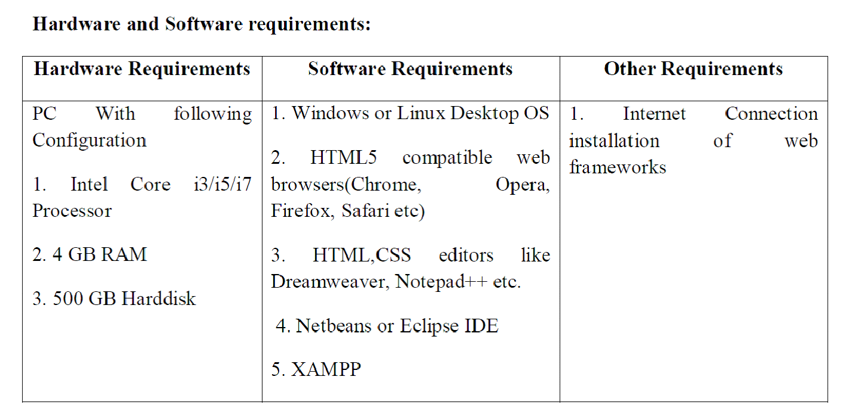

**Options of the Forum**

There are mainly four options are there,

* The user who is not a registered member can’t access the forum, he doesn’t have any control on it.
* The user who is able to login because they are the registered member having full control on forum.
* Administrator is having the full control on the whole forum and he can see the whole message and the topic of discussion. he can manage the topic also.
* The chatting facilities is also available where student can chat their query regarding any topic it is also recommended that no one should do any personal message as everyone can able to see the message.

**MODULES :-**

It is mainly consists of Five modules like,

* Home
* Login
* About
* Contact Us
* Logout

**Home:** It consists of the whole description of the website. In this the user interface will givethe information about the topics the latest research is going on basing on the software topics. It is like dashboard where all the modules or services will be visible to user which they will use.

**Login and Register:** ​ A new user can register to shop on the website. The site will keep track of the new user. Once registered the user can login any time for shopping.

**Contact us:** Here the admin contact information will be provided like the admin email id,phone number, facebook, tutor id etc. for any assistance students can contact to the admin. The location of the centre is also provided here which can help users to reach to us.

**Shopping Cart**: The products added by the customers to the cart are available for buying. The customers can easily checkout.

**RESPONSIVE WEB DESIGN FRAMEWORK**

**What is a framework?**

A framework is *a standardized set of concepts, practices and criteria for dealing with a common type* *of problem*, which can be used as a reference to help us approach and resolve new problems of asimilar nature.

In the world of web design, to give a more straightforward definition, a framework is defined as a *package made up of a structure of files and folders of standardized code (HTML, CSS, JS documents etc.)* which can be used to support the development of websites, as a basis to start building a site.

Most websites share a very similar (not to say identical) structure. The aim of frameworks is to provide a common structure so that developers don’t have to redo it from scratch and can reuse the code provided. In this way, frameworks allow us to cut out much of the work and save a lot of time.

**What is RWD?**

**Responsive web design** (**RWD**) is an approach to web design that makes web pages render well on a variety of devices and window or screen sizes.

Responsive web design makes your web page look good on all devices.

Responsive web design uses only HTML and CSS.

Responsive web design is not a program or a JavaScript.

**RWD- Viewport**

The viewport is the user's visible area of a web page.

The viewport varies with the device, and will be smaller on a mobile phone than on a computer screen.

Before tablets and mobile phones, web pages were designed only for computer screens, and it was common for web pages to have a static design and a fixed size.

Then, when we started surfing the internet using tablets and mobile phones, fixed size web pages were too large to fit the viewport. To fix this, browsers on those devices scaled down the entire web page to fit the screen.

**RWD- Media Query**

Media query is a CSS technique introduced in CSS3.

It uses the @media rule to include a block of CSS properties only if a certain condition is true.

**RWD- Frameworks**

There are many existing CSS Frameworks that offer Responsive Design.

They are free, and easy to use.

* Using W3.CSS

A great way to create a responsive design, is to use a responsive style sheet, like W3.CSS

W3.CSS makes it easy to develop sites that look nice at any size; desktop, laptop, tablet, or phone

* Bootstrap

Another popular framework is Bootstrap, it uses HTML, CSS and jQuery to make responsive web pages.

Responsive Code:

@media only screen and (max-width: 1600px){

}

@media only screen and (max-width: 1540px){

}

@media only screen and (max-width: 1380px){

}

@media only screen and (max-width: 1280px){

}

@media only screen and (max-width: 1199px){

.main_slider

{

min-height: 475px;

height: calc(100vw / 1.714);

}

.main_slider_content{

width: 80%;

}

.banner_item{

height: 220px;

}

.product-item{

height: 360px;

}

.product{

height: 320px;

}

.timer li{

width: 90px;

height: 90px;

}

.timer_num{

font-size: 36px;

font-weight: 500;

}

.timer_unit{

margin-top: 5px;

}

.blog_title{

font-size: 20px;

}

}

@media only screen and (max-width: 1024px){

}

@media only screen and (max-width: 991px){

h1{font-size: 48px;}

h2{font-size: 36px;}

.main_slider_content h6{

margin-bottom: 23px;

}

.shop_now_button{

margin-top: 26px;

}

.grid-item{

width: 25%;

}

.top_nav{

display: none;

}

.navbar_menu{

display: none;

}

.hamburger_container{

display: block;

}

.main_slider{

margin-top: 100px;

}

.main_slider_content{

width: 100%;

padding-right: 15px;

}

.banner_item{

height: 160px;

}

.banner_category{

min-width: 160px;

height: 40px;

}

.banner_category a{

font-size: 16px;

line-height: 40px;

}

.product-item{

width: 25%;

}

.deal_ofthe_week_col{

display: -webkit-box;

display: -moz-box;

display: -ms-flexbox;

display: -webkit-flex;

display: flex;

flex-direction: column;

justify-content: center;

align-items: center;

position: absolute;

top: 0;

left: 0;

width: 100%;

height: 100%;

}

.deal_ofthe_week_content{

position: relative;

top: auto;

left: auto;

height: auto;

}

.deal_ofthe_week_img{

text-align: center;

}

.timer li{

width: 70px;

height: 70px;

}

.timer_num{

font-size: 28px;

}

.timer_unit{

margin-top: 1px;

font-size: 14px;

}

.benefit_col{

margin-bottom: 30px;

}

.benefit_col:last-child{

margin-bottom: 0px;

}

.blog_item_col{

margin-bottom: 30px;

}

.blog_item_col:last-child{

margin-bottom: 0px;

}

.blog_item{

height: 440px;

}

.blog_title{

font-size: 24px;

}

.newsletter_text{

height: auto;

margin-top: 30px;

}

.newsletter_text p{

margin-top: 5px;

}

.newsletter_form{

height: auto;

margin-top: 30px;

margin-bottom: 40px;

}

.footer_nav_container{

height: auto;

margin-top: 65px;

}

.footer_social{

height: auto;

margin-top: 20px;

margin-bottom: 65px;

}

}

@media only screen and (max-width: 959px){

}

@media only screen and (max-width: 880px){

}

@media only screen and (max-width: 768px){

}

@media only screen and (max-width: 767px){

h1{font-size: 36px;}

h2{font-size: 24px;}

h6{font-size: 12px;}

.main_slider_content h6{

margin-bottom: 20px;

}

.shop_now_button{

margin-top: 23px;

}

.red_button a{

font-size: 12px;

}

.banner_item{

margin-bottom: 30px;

height: 210px;

}

.new_arrivals_title{

margin-top: 44px;

}

.product-item{

width: 33.333333333333%;

height: 345px;

}

.product{

height: 305px;

}

.grid_sorting_button{

font-size: 13px;

padding-left: 20px;

padding-right: 20px;

min-width: 80px;

}

.product_slider_container{

height: auto;

}

.product_slider_item .product-item{

height: 380px;

}

.benefit_col{

margin-bottom: 15px;

}

.blog_item{

height: 372px;

}

.newsletter_form{

margin-bottom: 40px;

}

.newsletter_submit_btn{

margin-top: 15px;

}

}

@media only screen and (max-width: 575px){

.hamburger_menu

{

right: -100%;

width: 100%;

}

.product-item{

width: 50%;

height: 420px;

}

.product{

height: 380px;

}

.blog_item{

height: calc((100vw - 30px) / 1.37);

}

.cr{

display: block;

margin-right: 0px;

margin-bottom: 30px;

font-size: 13px;

}

.footer_nav{

margin-bottom: 20px;

}

.footer_nav li{

display: block;

margin-right: 0px;

}

.footer_nav li a{

font-size: 13px;

}

}

@media only screen and (max-width: 539px){

}

@media only screen and (max-width: 480px){

}

@media only screen and (max-width: 479px){

.logo_container a{

font-size: 12px;

}

.hamburger_container{

margin-left: 25px;

}

.hamburger_container i{

font-size: 16px;

}

.hamburger_close{

top: 14px;

right: 4px;

}

.hamburger_close i{

font-size: 20px;

}

.hamburger_menu_content{

padding-right: 15px;

padding-top: 70px;

}

.menu_item{

border-bottom-color: rgba(181, 174, 196, 0.5);

}

.menu_item > a{

font-size: 12px;

line-height: 35px;

height: 35px;

}

.menu_selection li a{

font-size: 12px;

line-height: 35px;

height: 35px;

}

.navbar{

height: 70px;

}

.navbar_user li a{

width: 30px;

height: 30px;

font-size: 12px;

}

.checkout_items{

width: 15px;

height: 15px;

font-size: 10px;

}

.main_slider{

height: calc(100vh - 70px);

/*height: 80vw;*/

min-height: auto;

margin-top: 70px;

}

.main_slider_content h6{

margin-bottom: 15px;

}

.main_slider_content h1{

font-size: 24px;

}

.shop_now_button{

margin-top: 15px;

width: 100px;

height: 35px;

}

.red_button a{

font-size: 10px;

}

.banner_item{

height: calc((100vw - 30px) / 2.6);

}

.grid_sorting_button{

font-size: 12px;

padding-left: 10px;

padding-right: 10px;

min-width: 60px;

height: 35px;

}

.product-item{

width: 100%;

height: auto;

}

.product{

height: auto;

}

.product_name a{

font-size: 12px;

}

.add_to_cart_button{

margin-top: 20px;

}

.deal_ofthe_week_img{

height: 400px;

}

.timer{

margin-top: 42px;

}

.timer li{

width: 50px;

height: 50px;

}

.section_title::after{

top: calc(100% + 8px);

height: 3px;

}

.timer_num{

margin-top: 4px;

font-size: 16px;

}

.timer_unit{

margin-top: -9px;

font-size: 10px;

}

.deal_ofthe_week_button{

margin-top: 36px;

}

.product_slider_item .product-item{

width: 100%;

height: auto;

}

.product_slider_item .product-item:hover::after{

box-shadow: none;

}

.product_slider_item .product-item .product{

height: auto;

}

.product_slider_item .product-item .product_info{

padding-bottom: 30px;

}

.blog_title{

font-size: 16px;

}

.blog_meta{

font-size: 10px;

}

.blog_more{

font-size: 12px;

margin-top: 5px;

}

.newsletter_form{

margin-top: 22px;

}

.newsletter_text h4{

font-size: 20px;

}

.newsletter_text p{

font-size: 13px;

margin-top: 5px;

}

.newsletter_submit_btn{

font-size: 12px;

}

#newsletter_email{

height: 40px;

width: 100%;

padding-left: 15px;

}

.newsletter_submit_btn{

height: 36px;

width: 130px;

}

#newsletter_email::-webkit-input-placeholder{

font-size: 12px !important;

padding-left: 0px;

}

#newsletter_email:-moz-placeholder /* older Firefox*/{

font-size: 12px !important;

padding-left: 0px;

}

#newsletter_email::-moz-placeholder /* Firefox 19+ */{

font-size: 12px !important;

padding-left: 0px;

}

#newsletter_email:-ms-input-placeholder{

font-size: 12px !important;

padding-left: 0px;

}

#newsletter_email::input-placeholder{

font-size: 12px !important;

padding-left: 0px;

}

.footer_nav_container{

margin-top: 35px;

}

.cr{

margin-bottom: 20px;

}

.footer_nav{

margin-bottom: 20px;

}

.footer_social{

margin-top: 5px;

margin-bottom: 30px;

}

}

@media only screen and (max-width: 400px){

}

**HTML CODE**

Index.html

<!DOCTYPE html>

<html lang="en">

<head>

<title>Foot Steps</title>

<meta charset="utf-8">

<meta http-equiv="X-UA-Compatible" content="IE=edge">

<meta name="description" content="Colo Shop Template">

<meta name="viewport" content="width=device-width, initial-scale=1">

<link rel="stylesheet" type="text/css" href="styles/bootstrap4/bootstrap.min.css">

<link href="plugins/font-awesome-4.7.0/css/font-awesome.min.css" rel="stylesheet" type="text/css">

<link rel="stylesheet" type="text/css" href="plugins/OwlCarousel2-2.2.1/owl.carousel.css">

<link rel="stylesheet" type="text/css" href="plugins/OwlCarousel2-2.2.1/owl.theme.default.css">

<link rel="stylesheet" type="text/css" href="plugins/OwlCarousel2-2.2.1/animate.css">

<link rel="stylesheet" type="text/css" href="styles/main_styles.css">

<link rel="stylesheet" type="text/css" href="styles/responsive.css">

</head>

<body>

<div class="super_container">

<!-- Header -->

<header class="header trans_300">

<!-- Top Navigation -->

<div class="top_nav">

<div class="container">

<div class="row">

<div class="col-md-6">

<div class="top_nav_left">free shipping on all orders over Rs.999</div>

</div>

<div class="col-md-6 text-right">

<div class="top_nav_right">

<ul class="top_nav_menu">

</ul>

</div>

</div>

</div>

</div>

</div>

<!-- Main Navigation -->

<div class="main_nav_container">

<div class="container">

<div class="row">

<div class="col-lg-12 text-right">

<div class="logo_container">

<a href="#">foot<span>steps</span></a>

</div>

<nav class="navbar">

<ul class="navbar_menu">

<li><a href="index.html">home</a></li>

<li><a href="contact.html">contact</a></li>

</ul>

<ul class="navbar_user">

<li class="account"><a href="#"><i class="fa fa-user" aria-hidden="true"></i></a>

<ul class="account_selection">

<li><a href="login.php"><i class="fa fa-sign-in" aria-hidden="true"></i>SignIn</a></li>

<li><a href="register.php"><i class="fa fa-user-plus" aria-hidden="true"></i>Register</a></li>

</ul>

</li>

<li class="checkout">

<a href="#">

<i class="fa fa-shopping-cart" aria-hidden="true"></i>

<span id="checkout_items" class="checkout_items">2</span>

</a>

</li>

</ul>

<div class="hamburger_container">

<i class="fa fa-bars" aria-hidden="true"></i>

</div>

</nav>

</div>

</div>

</div>

</div>

</header>

<div class="fs_menu_overlay"></div>

<div class="hamburger_menu">

<div class="hamburger_close"><i class="fa fa-times" aria-hidden="true"></i></div>

<div class="hamburger_menu_content text-right">

<ul class="menu_top_nav">

<li class="menu_item has-children">

<a href="#">

usd

<i class="fa fa-angle-down"></i>

</a>

<ul class="menu_selection">

<li><a href="#">usd</a></li>

<li><a href="#">cad</a></li>

<li><a href="#">aud</a></li>

<li><a href="#">eur</a></li>

<li><a href="#">gbp</a></li>

</ul>

</li>

<li class="menu_item has-children">

<a href="#">

English

<i class="fa fa-angle-down"></i>

</a>

<ul class="menu_selection">

<li><a href="#">Hindi</a></li>

<li><a href="#">French</a></li>

<li><a href="#">Italian</a></li>

<li><a href="#">German</a></li>

<li><a href="#">Spanish</a></li>

</ul>

</li>

<li class="menu_item has-children">

<a href="#">

My Account

<i class="fa fa-angle-down"></i>

</a>

<ul class="menu_selection">

<li><a href="#"><i class="fa fa-sign-in" aria-hidden="true"></i>Sign In</a></li>

<li><a href="#"><i class="fa fa-user-plus" aria-hidden="true"></i>Register</a></li>

</ul>

</li>

<li class="menu_item"><a href="#">home</a></li>

<li class="menu_item"><a href="#">shop</a></li>

<li class="menu_item"><a href="#">promotion</a></li>

<li class="menu_item"><a href="#">pages</a></li>

<li class="menu_item"><a href="#">blog</a></li>

<li class="menu_item"><a href="#">contact</a></li>

</ul>

</div>

</div>

<!-- Slider -->

<div class="main_slider" style="background-image:url(images/slider_1.gif)">

<div class="container fill_height">

<div class="row align-items-center fill_height">

<div class="col">

<div class="main_slider_content">

<div class="red_button shop_now_button"><a href="#new-arrivals">shop now</a></div>

</div>

</div>

</div>

</div>

</div>

<!-- New Arrivals -->

<div id="new-arrivals"class="new_arrivals">

<div class="container">

<div class="row">

<div class="col text-center">

<div class="section_title new_arrivals_title">

<h2>New Arrivals</h2>

</div>

</div>

</div>

<div class="row align-items-center">

<div class="col text-center">

<div class="new_arrivals_sorting">

<ul class="arrivals_grid_sorting clearfix button-group filters-button-group">

<li class="grid_sorting_button button d-flex flex-column justify-content-center align-items-center active is-checked" data-filter="*">all</li>

<li class="grid_sorting_button button d-flex flex-column justify-content-center align-items-center" data-filter=".women">women's</li>

<li class="grid_sorting_button button d-flex flex-column justify-content-center align-items-center" data-filter=".men">men's</li>

</ul>

</div>

</div>

</div>

<div class="row">

<div class="col">

<div class="product-grid" data-isotope='{ "itemSelector": ".product-item", "layoutMode": "fitRows" }'>

<!-- Product 1 -->

<div class="product-item men">

<div class="product discount product_filter">

<div class="product_image">

<img src="images/Adidas%20Men_s%20Agora%201.0%20Multisport%20Training%20Shoes.png" alt="adidas">

</div>

<div class="favorite favorite_left"></div>

<div class="product_bubble product_bubble_right product_bubble_red d-flex flex-column align-items-center"><span>10%off</span></div>

<div class="product_info">

<h6 class="product_name"><a href="single.html">Adidas Men's Agora 1.0 Multisport Training Shoes</a></h6>

<div class="product_price">Rs999<span>Rs1299</span></div>

</div>

</div>

<div class="red_button add_to_cart_button"><a href="#">add to cart</a></div>

</div>

<!-- Product 2 -->

<div class="product-item women">

<div class="product product_filter">

<div class="product_image">

<img src="images/Puma Men_s Running Shoes.png" alt="puma">

</div>

<div class="favorite"></div>

<div class="product_bubble product_bubble_left product_bubble_green d-flex flex-column align-items-center"><span>new</span></div>

<div class="product_info">

<h6 class="product_name"><a href="single.html">Puma Men's Running Shoes</a></h6>

<div class="product_price">Rs2999</div>

</div>

</div>

<div class="red_button add_to_cart_button"><a href="#">add to cart</a></div>

</div>

<!-- Product 3 -->

<div class="product-item women">

<div class="product product_filter">

<div class="product_image">

<img src="images/Vans%20Unisex%20Authentic%20Sneakers.png" alt="">

</div>

<div class="favorite"></div>

<div class="product_info">

<h6 class="product_name"><a href="single.html">Vans Unisex Authentic Sneakers</a></h6>

<div class="product_price">Rs1099</div>

</div>

</div>

<div class="red_button add_to_cart_button"><a href="#">add to cart</a></div>

</div>

<!-- Product 4 -->

<div class="product-item children's">

<div class="product product_filter">

<div class="product_image">

<img src="images/Red Tape Women_s Running Shoes.png" alt="">

</div>

<div class="product_bubble product_bubble_right product_bubble_red d-flex flex-column align-items-center"><span>sale</span></div>

<div class="favorite favorite_left"></div>

<div class="product_info">

<h6 class="product_name"><a href="single.html">Red Tape Women's Running Shoes</a></h6>

<div class="product_price">Rs1999</div>

</div>

</div>

<div class="red_button add_to_cart_button"><a href="#">add to cart</a></div>

</div>

<!-- Product 5 -->

<div class="product-item women men">

<div class="product product_filter">

<div class="product_image">

<img src="images/Puma%20Unisex%20Dare%20Jr%20Sneakers.png" alt="">

</div>

<div class="favorite"></div>

<div class="product_info">

<h6 class="product_name"><a href="single.html">Puma Unisex Dare Jr Sneakers</a></h6>

<div class="product_price">Rs1599</div>

</div>

</div>

<div class="red_button add_to_cart_button"><a href="#">add to cart</a></div>

</div>

<!-- Product 6 -->

<div class="product-item children's">

<div class="product discount product_filter">

<div class="product_image">

<img src="images/Puma%20Unisex%20Running%20Shoes.png" alt="">

</div>

<div class="favorite favorite_left"></div>

<div class="product_bubble product_bubble_right product_bubble_red d-flex flex-column align-items-center"><span>10%off</span></div>

<div class="product_info">

<h6 class="product_name"><a href="#single.html">Puma Unisex Running Shoes</a></h6>

<div class="product_price">Rs899<span>Rs1499</span></div>

</div>

</div>

<div class="red_button add_to_cart_button"><a href="#">add to cart</a></div>

</div>

</div>

</div>

</div>

</div>

</div>

<!-- Deal of the week -->

<div class="deal_ofthe_week">

<div class="container">

<div class="row align-items-center">

<div class="col-lg-6">

<div class="deal_ofthe_week_img">

<img src="" alt="">

</div>

</div>

<div class="col-lg-6 text-right deal_ofthe_week_col">

<div class="deal_ofthe_week_content d-flex flex-column align-items-center float-right">

<div class="section_title">

<h2>Deal Of The Week</h2>

</div>

<ul class="timer">

<li class="d-inline-flex flex-column justify-content-center align-items-center">

<div id="day" class="timer_num">03</div>

<div class="timer_unit">Day</div>

</li>

<li class="d-inline-flex flex-column justify-content-center align-items-center">

<div id="hour" class="timer_num">15</div>

<div class="timer_unit">Hours</div>

</li>

<li class="d-inline-flex flex-column justify-content-center align-items-center">

<div id="minute" class="timer_num">45</div>

<div class="timer_unit">Mins</div>

</li>

<li class="d-inline-flex flex-column justify-content-center align-items-center">

<div id="second" class="timer_num">23</div>

<div class="timer_unit">Sec</div>

</li>

</ul>

<div class="red_button deal_ofthe_week_button"><a href="#new-arrivals">shop now</a></div>

</div>

</div>

</div>

</div>

</div>

<!-- Benefit -->

<div class="benefit">

<div class="container">

<div class="row benefit_row">

<div class="col-lg-3 benefit_col">

<div class="benefit_item d-flex flex-row align-items-center">

<div class="benefit_icon"><i class="fa fa-truck" aria-hidden="true"></i></div>

<div class="benefit_content">

<h6>free shipping</h6>

<p>All orders above Rs.999</p>

</div>

</div>

</div>

<div class="col-lg-3 benefit_col">

<div class="benefit_item d-flex flex-row align-items-center">

<div class="benefit_icon"><i class="fa fa-money" aria-hidden="true"></i></div>

<div class="benefit_content">

<h6>cash on delivery</h6>

<p>Easy to track orders</p>

</div>

</div>

</div>

<div class="col-lg-3 benefit_col">

<div class="benefit_item d-flex flex-row align-items-center">

<div class="benefit_icon"><i class="fa fa-undo" aria-hidden="true"></i></div>

<div class="benefit_content">

<h6>45 days return</h6>

<p>Return or Exchange products</p>

</div>

</div>

</div>

<div class="col-lg-3 benefit_col">

<div class="benefit_item d-flex flex-row align-items-center">

<div class="benefit_icon"><i class="fa fa-clock-o" aria-hidden="true"></i></div>

<div class="benefit_content">

<h6>weekly sales</h6>

<p>3 days each week</p>

</div>

</div>

</div>

</div>

</div>

</div>

<!-- Blogs -->

<div class="blogs">

<div class="container">

<div class="row">

<div class="col text-center">

<div class="section_title">

<h2>Latest Blogs</h2>

</div>

</div>

</div>

<div class="row blogs_container">

<div class="col-lg-4 blog_item_col">

<div class="blog_item">

<div class="blog_background" style="background-image:url(images/blog_1.jpg)"></div>

<div class="blog_content d-flex flex-column align-items-center justify-content-center text-center">

<h4 class="blog_title">Here are the trends I see coming this fall</h4>

<span class="blog_meta">by admin | oct 15, 2018</span>

<a class="blog_more" href="https://www.office.co.uk/blog/">Read more</a>

</div>

</div>

</div>

<div class="col-lg-4 blog_item_col">

<div class="blog_item">

<div class="blog_background" style="background-image:url(images/blog_2.jpg)"></div>

<div class="blog_content d-flex flex-column align-items-center justify-content-center text-center">

<h4 class="blog_title">Trends for Men</h4>

<span class="blog_meta">by admin | aug 21, 2018</span>

<a class="blog_more" href="http://www.theshoesnobblog.com/tag/mens-shoes">Read more</a>

</div>

</div>

</div>

<div class="col-lg-4 blog_item_col">

<div class="blog_item">

<div class="blog_background" style="background-image:url(images/blog_3.png)"></div>

<div class="blog_content d-flex flex-column align-items-center justify-content-center text-center">

<h4 class="blog_title">Trends for Women</h4>

<span class="blog_meta">by admin | sept 14, 2018</span>

<a class="blog_more" href="https://www.shoe-tease.com/category/shoe-trends-2/">Read more</a>

</div>

</div>

</div>

</div>

</div>

</div>

<!-- Footer -->

<footer class="footer">

<div class="container">

<div class="row">

<div class="col-lg-6">

<div class="footer_nav_container d-flex flex-sm-row flex-column align-items-center justify-content-lg-start justify-content-center text-center">

<ul class="footer_nav">

<li><a href="#">Blog</a></li>

<li><a href="#">FAQs</a></li>

<li><a href="contact.html">Contact us</a></li>

</ul>

</div>

</div>

<div class="col-lg-6">

<div class="footer_social d-flex flex-row align-items-center justify-content-lg-end justify-content-center">

<ul>

<li><a href="#"><i class="fa fa-facebook" aria-hidden="true"></i></a></li>

<li><a href="#"><i class="fa fa-twitter" aria-hidden="true"></i></a></li>

<li><a href="#"><i class="fa fa-instagram" aria-hidden="true"></i></a></li>

<li><a href="#"><i class="fa fa-skype" aria-hidden="true"></i></a></li>

<li><a href="#"><i class="fa fa-pinterest" aria-hidden="true"></i></a></li>

</ul>

</div>

</div>

</div>

</div>

</footer>

</div>

<script src="js/jquery-3.2.1.min.js"></script>

<script src="styles/bootstrap4/popper.js"></script>

<script src="styles/bootstrap4/bootstrap.min.js"></script>

<script src="plugins/Isotope/isotope.pkgd.min.js"></script>

<script src="plugins/OwlCarousel2-2.2.1/owl.carousel.js"></script>

<script src="plugins/easing/easing.js"></script>

<script src="js/custom.js"></script>

</body>

</html>

Navbar.html

<!DOCTYPE html>

<html lang="en">

<head>

<title>Foot Steps</title>

<meta charset="utf-8">

<meta http-equiv="X-UA-Compatible" content="IE=edge">

<meta name="description" content="Colo Shop Template">

<meta name="viewport" content="width=device-width, initial-scale=1">

<link rel="stylesheet" type="text/css" href="styles/bootstrap4/bootstrap.min.css">

<link href="plugins/font-awesome-4.7.0/css/font-awesome.min.css" rel="stylesheet" type="text/css">

<link rel="stylesheet" type="text/css" href="plugins/OwlCarousel2-2.2.1/owl.carousel.css">

<link rel="stylesheet" type="text/css" href="plugins/OwlCarousel2-2.2.1/owl.theme.default.css">

<link rel="stylesheet" type="text/css" href="plugins/OwlCarousel2-2.2.1/animate.css">

<link rel="stylesheet" type="text/css" href="styles/main_styles.css">

<link rel="stylesheet" type="text/css" href="styles/responsive.css">

</head>

<body>

<div class="super_container">

<!-- Header -->

<header class="header trans_300">

<!-- Top Navigation -->

<div class="top_nav">

<div class="container">

<div class="row">

<div class="col-md-6">

<div class="top_nav_left">free shipping on all orders over Rs.499</div>

</div>

<div class="col-md-6 text-right">

<div class="top_nav_right">

</div>

</div>

</div>

</div>

</div>

<!-- Main Navigation -->

<div class="main_nav_container">

<div class="container">

<div class="row">

<div class="col-lg-12 text-right">

<div class="logo_container">

<a href="#">foot<span>steps</span></a>

</div>

<nav class="navbar">

<ul class="navbar_menu">

<li><a href="index.html">home</a></li>

<li><a href="contact.html">contact</a></li>

</ul>

<ul class="navbar_user">

<li class="account"><a href="#"><i class="fa fa-user" aria-hidden="true"></i></a>

<ul class="account_selection">

<li><a href="login.php"><i class="fa fa-sign-in" aria-hidden="true"></i>SignIn</a></li>

<li><a href="register.php"><i class="fa fa-user-plus" aria-hidden="true"></i>Register</a></li>

</ul>

</li>

<li class="checkout">

<a href="#">

<i class="fa fa-shopping-cart" aria-hidden="true"></i>

<span id="checkout_items" class="checkout_items">2</span>

</a>

</li>

</ul>

<div class="hamburger_container">

<i class="fa fa-bars" aria-hidden="true"></i>

</div>

</nav>

</div>

</div>

</div>

</div>

</header>

**CSS PREPROCESSOR**

**TYPES OF CSS**

**CSS comes in three types:**

* In a separate file (**external**)
* At the top of a web page document (**internal**)
* Right next to the text it decorates (**inline**)

**External** style sheets are separate files full of CSS instructions (with the file extension .css). Whenany web page includes an external stylesheet, its look and feel will be controlled by this CSS file (unless you decide to override a style using one of these next two types). This is how you change a whole website at once. And that's perfect if you want to keep up with the latest fashion in web pages without rewriting every page!

**Internal** styles are placed at the top of each web page document, before any of the content is listed.This is the next best thing to external, because they're easy to find, yet allow you to 'override' an external style sheet -- for that special page that wants to be a nonconformist!

**Inline** styles are placed right where you need them, next to the text or graphic you wish to decorate.You can insert inline styles anywhere in the middle of your HTML code, giving you real freedom to specify each web page element. On the other hand, this can make maintaining web pages a real chore!

CSS3 modules

CSS3 is collaboration of CSS2 specifications and new specifications, we can called this collaboration is **module**. Some of the modules are shown below −

* Selectors
* Box Model
* Backgrounds
* Image Values and Replaced Content
* Text Effects
* 2D Transformations
* 3D Transformations
* Animations

**CSS3 CODE**

.main_slider{

width: 100%;

height: 700px;

background-repeat: no-repeat;

background-size: cover;

background-position: center center;

margin-top: 150px;

}

.main_slider_content{

width: 60%;

}

.main_slider_content h6{

font-weight: 500;

text-transform: uppercase;

margin-bottom: 29px;

}

.main_slider_content h1{

font-weight: 400;

line-height: 1;

}

.red_button{

display: -webkit-inline-box;

display: -moz-inline-box;

display: -ms-inline-flexbox;

display: -webkit-inline-flex;

display: inline-flex;

flex-direction: column;

justify-content: center;

align-items: center;

width: auto;

height: 40px;

background: #fe4c50;

border-radius: 3px;

-webkit-transition: all 0.3s ease;

-moz-transition: all 0.3s ease;

-ms-transition: all 0.3s ease;

-o-transition: all 0.3s ease;

transition: all 0.3s ease;

}

.red_button:hover{

background: #FE7C7F !important;

}

.red_button a{

display: block;

color: #FFFFFF;

text-transform: uppercase;

font-size: 14px;

font-weight: 500;

text-align: center;

line-height: 40px;

width: 100%;

}

.shop_now_button{

width: 140px;

margin-top: 32px;

}

.banner{

width: 100%;

margin-top: 30px;

}

.banner_item{

display: -webkit-box;

display: -moz-box;

display: -ms-flexbox;

display: -webkit-flex;

display: flex;

flex-direction: column;

justify-content: center;

align-items: center;

height: 265px;

background-repeat: no-repeat;

background-size: cover;

background-position: center center;

}

.banner_category{

height: 50px;

background: #FFFFFF;

min-width: 180px;

padding-left: 25px;

padding-right: 25px;

}

.banner_category a{

display: block;

color: #1e1e27;

text-transform: uppercase;

font-size: 22px;

font-weight: 600;

text-align: center;

line-height: 50px;

width: 100%;

-webkit-transition: color 0.3s ease;

-moz-transition: color 0.3s ease;

-ms-transition: color 0.3s ease;

-o-transition: color 0.3s ease;

transition: color 0.3s ease;

}

.banner_category a:hover{

color: #b5aec4;

}

.new_arrivals{

width: 100%;

}

.new_arrivals_title{

margin-top: 74px;

}

.new_arrivals_sorting{

display: inline-block;

border-radius: 3px;

margin-top: 59px;

overflow: visible;

}

.grid_sorting_button{

height: 40px;

min-width: 102px;

padding-left: 25px;

padding-right: 25px;

cursor: pointer;

border: solid 1px #ebebeb;

font-size: 14px;

font-weight: 500;

text-transform: uppercase;

background: #FFFFFF;

border-radius: 3px;

margin: 0;

float: left;

margin-left: -1px;

}

.grid_sorting_button:first-child{

margin-left: 0px;

}

.grid_sorting_button:last-child{

}

.grid_sorting_button.active:hover{

background: #FE7C7F !important;

}

.grid_sorting_button.active{

color: #FFFFFF;

background: #fe4c50;

}

.product-grid{

width: 100%;

margin-top: 57px;

}

.product-item{

width: 20%;

height: 380px;

cursor: pointer;

}

.product-item::after{

display: block;

position: absolute;

top: 0;

left: -1px;

width: calc(100% + 1px);

height: 100%;

pointer-events: none;

content: '';

border: solid 2px rgba(235,235,235,0);

border-radius: 3px;

-webkit-transition: all 0.3s ease;

-moz-transition: all 0.3s ease;

-ms-transition: all 0.3s ease;

-o-transition: all 0.3s ease;

transition: all 0.3s ease;

}

.product-item:hover::after{

box-shadow: 0 25px 29px rgba(63, 78, 100, 0.15);

border: solid 2px rgba(235,235,235,1);

}

.product{

width: 100%;

height: 340px;

border-right: solid 1px #e9e9e9;

}

.product_image{

width: 100%;

}

.product_image img{

width: 100%;

}

.product_info{

text-align: center;

padding-left: 10px;

padding-right: 10px;

}

.product_name{

margin-top: 27px;

}

.product_name a{

color: #1e1e27;

line-height: 20px;

}

.product_name:hover a{

color: #b5aec4;

}

.discount .product_info .product_price{

font-size: 14px;

}

.product_price{

font-size: 16px;

color: #fe4c50;

font-weight: 600;

}

.product_price span{

font-size: 12px;

margin-left: 10px;

color: #b5aec4;

text-decoration: line-through;

}

.product_bubble{

position: absolute;

top: 15px;

width: 50px;

height: 22px;

border-radius: 3px;

text-transform: uppercase;

}

.product_bubble span{

font-size: 12px;

font-weight: 600;

color: #FFFFFF;

}

.product_bubble_right::after{

content: ' ';

position: absolute;

width: 0;

height: 0;

left: 6px;

right: auto;

top: auto;

bottom: -6px;

border: 6px solid;

}

.product_bubble_left::after{

content: ' ';

position: absolute;

width: 0;

height: 0;

left: auto;

right: 6px;

bottom: -6px;

border: 6px solid;

}

.product_bubble_red::after{

border-color: transparent transparent transparent #fe4c50;

}

.product_bubble_left::after{

border-color: #51a042 #51a042 transparent transparent;

}

.product_bubble_red{

background: #fe4c50;

}

.product_bubble_green{

background: #51a042;

}

.product_bubble_left{

left: 15px;

}

.product_bubble_right{

right: 15px;

}

.add_to_cart_button{ width: 100%;

visibility: hidden;

opacity: 0;

-webkit-transition: all 0.3s ease;

-moz-transition: all 0.3s ease;

-ms-transition: all 0.3s ease;

-o-transition: all 0.3s ease;

transition: all 0.3s ease;

}

.add_to_cart_button a{

font-size: 12px;

font-weight: 600;

}

.product-item:hover .add_to_cart_button{

visibility: visible;

opacity: 1;

}

.favorite{

position: absolute;

top: 15px;

right: 15px;

color: #b9b4c7;

width: 17px;

height: 17px;

visibility: hidden;

opacity: 0;

}

.favorite_left{

left: 15px;

}

.favorite.active{

visibility: visible;

opacity: 1;

}

.product-item:hover .favorite

{visibility: visible;

opacity: 1;

}

.favorite.active::after{

font-family: 'FontAwesome';

content:'\f004';

color: #fe4c50;

}

.favorite::after{

font-family: 'FontAwesome';

content:'\f08a';

}

.favorite:hover::after{

color: #fe4c50;

}

.deal_ofthe_week{

width: 100%;

margin-top: 41px;

background: #f2f2f2;

}

.deal_ofthe_week_img{

height: 540px;

}

.deal_ofthe_week_img img{

height: 100%;

}

.deal_ofthe_week_content{

height: 100%;

}

.section_title{

display: inline-block;

text-align: center;

}

.section_title h2{

display: inline-block;

}

.section_title::after{

display: block;

position: absolute;

top: calc(100% + 13px);

left: 50%;

-webkit-transform: translateX(-50%);

-moz-transform: translateX(-50%);

-ms-transform: translateX(-50%);

-o-transform: translateX(-50%);

transform: translateX(-50%);

width: 60px;

height: 5px;

background: #fe4c50;

content: '';

}

.timer{

margin-top: 66px;

}

.timer li{

display: inline-block;

width: 120px;

height: 120px;

border-radius: 50%;

background: #FFFFFF;

margin-right: 10px;

}

.timer li:last-child{

margin-right: 0px;

}

.timer_num{

font-size: 48px;

font-weight: 600;

color: #fe4c50;

margin-top: 10px;

}

.timer_unit{

margin-top: 12px;

font-size: 16px;

font-weight: 500;

color: #51545f;

}

.deal_ofthe_week_button{

width: 140px;

background: #1e1e27;

margin-top: 52px;

}

.deal_ofthe_week_button:hover{

background: #2b2b34 !important;

}

**SKELETON OF WEBSITE**

Architecture and Flow of the Website.

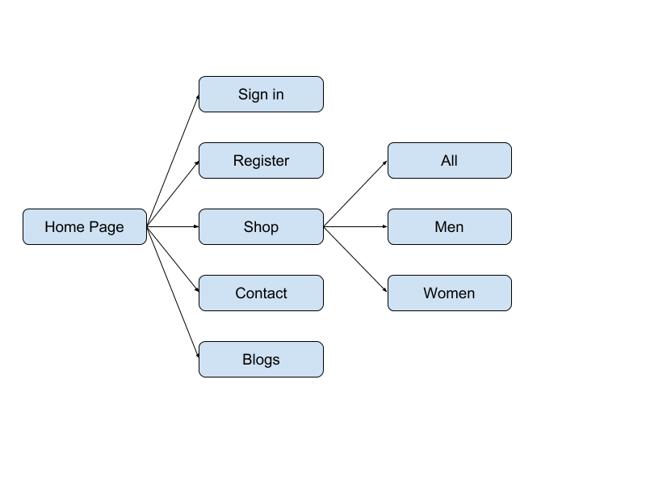

**SERVER SIDE PROGRAMMING in PHP**

The PHP Hypertext Preprocessor (PHP) is a programming language that allows web developers to create dynamic content that interacts with databases.

PHP is basically used for developing web based software applications.

**PHP Sessions**

An alternative way to make data accessible across the various pages of an entire website is to use a PHP Session.

A session creates a file in a temporary directory on the server where registered session When a PHP script wants to retrieve the value from a session variable, PHP automatically gets the unique session identifier string from the PHPSESSID cookie and then looks in its temporary directory for the file bearing that name and a validation can be done by comparing both values.

A session ends when the user loses the browser or after leaving the site, the server will terminate the session after a predetermined period of time, commonly 30 minutes duration variables and their values are stored.

**PHP CODE**

Login.php

<?php

session_start();

include "navbar.php"

?>

<section id="login">

<header class="section-header wow fadeInUp">

<h3>Login</h3>

</header>

<?php

if (isset($_SESSION['u_id'])) {

header("Location: index.html");

} else {

$url = "http://".$_SERVER['HTTP_HOST'].$_SERVER['REQUEST_URI'];

if (strpos($url, "login=error") !== false) {

echo '<div class="col-md-4 offset-md-4 col-sm-4 offset-sm-4 text-center alert alert-danger" role="alert">

Invalid Email / Password

</div>';

} elseif (strpos($url, "login=empty") !== false) {

echo '<div class="col-md-4 offset-md-4 col-sm-4 offset-sm-4 text-center alert alert-danger" role="alert">

Fill out all the fields!

</div>';

}

echo

"<form class=\"center\" action=\"includes/login.inc.php\" method=\"POST\">

<div>

<label class=\"padding\" for=\"email\">

<b>Email</b>

</label>

<br>

<input type=\"text\" style=\"text-align: center;\" placeholder=\"Enter Email\" name=\"email\">

<br>

<label class=\"padding\" for=\"psw\">

<b>Password</b>

</label>

<br>

<input type=\"password\" style=\"text-align: center;\" placeholder=\"Enter Password\" name=\"pass\">

<br>

</div>

<button class=\"top mt-4 mb-3\" name=\"submit\">Login</button><br>

<a href=\"forgot_password.php\">Forgot Password</a><br><br>

</form>";

}

?>

<?php include "footer.php";?>

<?php

//Now this page can have sessions

session_start();

include_once 'connect.local.php';

if(isset($_POST['submit'])) {

$email = mysqli_real_escape_string($conn, $_POST['email']);

$pass = mysqli_real_escape_string($conn, $_POST['pass']);

//Error Handlers

// Check if inputs are empty

if(empty($email) || empty($pass)) {

header("Location: ../login.php?login=empty");

exit();

} else {

$sql = "SELECT * FROM users where email='$email';";

$result = mysqli_query($conn, $sql);

$resultCheck = mysqli_num_rows($result);

if($resultCheck < 1) {

header("Location: ../login.php?login=error");

exit();

} else {

if($row = mysqli_fetch_assoc($result)) {

// Dehashing the password

$hashedPassCheck = password_verify($pass, $row['pass']);

if($hashedPassCheck == false) {

header("Location: ../login.php?login=error");

exit();

} elseif($hashedPassCheck == true) {

// Login the user here use a common variable called $_SESSION

$_SESSION['u_id'] = $row[' id'];

$_SESSION['u_first'] = $row[' firstname'];

$_SESSION['u_last'] = $row[' lastname'];

$_SESSION['u_email'] = $row[' email'];

$_SESSION['u_contact'] = $row[' contact'];

if(strcmp($email, "admin@ieee.com") == 0) {

$_SESSION['privilege'] = "admin";

} else {

$_SESSION['privilege'] = "member";

}

header("Location: ../shoes.php");

exit();

}

}

}

}

} else {

header("Location: ../login.php");

exit();

}

**PHP**

Connect Database

To connect to MySQL DataBase using PHP

There are several methods for connecting to a MySQL database using PHP:

* MySQL Improved (mysqli) extension
* PDO (PHP Data Objects)
* Legacy MySQL (mysql_) functions

For our project we have used First one mysqli extension to connect Database

Code:

<?php

session_start();

if(isset($_SESSION['u_id'])) {

//User is logged in

header("Location: index.php");

exit();

}

include "navbar.php"

?>

<section id="login">

<header class="section-header wow fadeInUp">

<h3>Membership Form</h3>

</header>

<?php

//Error Handling

// $_SERVER['HTTP_HOST'] gives http://localhost

// $_SERVER['HTTP_HOST'].$_SERVER['REQUEST_URI'] givees http://localhost/admissions.php?error EvWatcher

$url = "http://".$_SERVER['HTTP_HOST'].$_SERVER['REQUEST_URI'];

if (strpos($url, "signup=empty") !== false) {

echo '<div class="col-md-4 offset-md-4 col-sm-4 offset-sm-4 text-center alert alert-danger" role="alert">

Fill out all the fields!

</div>';

} elseif (strpos($url, "signup=invalid")!== false) {

echo '<div class="col-md-4 offset-md-4 col-sm-4 offset-sm-4 text-center alert alert-danger lastname" role="alert">

Invalid Characters in Name

</div>';

} elseif (strpos($url, "signup=email")!== false) {

echo '<div class="col-md-4 offset-md-4 col-sm-4 offset-sm-4 text-center alert alert-danger lastname" role="alert">

Invalid Email

</div>';

} elseif (strpos($url, "signup=taken")!== false) {

echo '<div class="col-md-4 offset-md-4 col-sm-4 offset-sm-4 text-center alert alert-danger lastname" role="alert">

User already exists

</div>';

} elseif (strpos($url, "signup=pass")!== false) {

echo '<div class="col-md-4 offset-md-4 col-sm-4 offset-sm-4 text-center alert alert-danger lastname" role="alert">

The passwords do not match

</div>';

} elseif (strpos($url, "signup=len")!== false) {

echo '<div class="col-md-4 offset-md-4 col-sm-4 offset-sm-4 text-center alert alert-danger lastname" role="alert">

Password too short (min. 8 char)

</div>';

} elseif (strpos($url, "signup=contact")!== false) {

echo '<div class="col-md-4 offset-md-4 col-sm-4 offset-sm-4 text-center alert alert-danger lastname" role="alert">

Invalid Phone no

</div>';

} elseif (strpos($url, "signup=success")!== false) {

// Wait for 5 seconds and then redirect user to login page

header("refresh:2; url=login.php");

echo '<div class="col-md-4 offset-md-4 col-sm-4 offset-sm-4 text-center alert alert-success">Account created, Redirecting..</div>';

}

//Focus on ip tag and add div container

?>

<div class="mobileHide">

<form class="contact-form center" action="includes/register.inc.php" method="POST" enctype="multipart/form-data">

<section id="contact" class="section-bg wow fadeInUp">

<div class="container">

<div class="form">

<div class="form-row">

<div class="form-group offset-md-1 col-md-3 mt-2">

<label for="lastname">Last Name</label>

</div>

<div class="form-group col-md-6">

<?php

if(isset($_SESSION['formFilled']))

echo'<input id="lastname" type="text" name="lastname" class="form-control" value="'.$_SESSION['lastname'].'" placeholder="Enter Lastname"/>';

else

echo'<input id="lastname" type="text" name="lastname" class="form-control" placeholder="Enter Lastname"/>'

?>

</div>

</div>

<div class="form-row">

<div class="form-group offset-md-1 col-md-3 mt-2">

<label for="firstname">First Name</label>

</div>

<div class="form-group col-md-6">

<?php

if(isset($_SESSION['formFilled']))

echo'<input type="text" class="form-control" name="firstname" value="'.$_SESSION['firstname'].'" placeholder="Enter Firstname"/>';

else

echo'<input type="text" class="form-control" name="firstname" placeholder="Enter Firstname"/>'

?>

</div>

</div>

</div>

<div class="form-row">

<div class="form-group offset-md-1 col-md-3 mt-2">

<label for="email">Email</label>

</div>

<div class="form-group col-md-6">

<?php if(isset($_SESSION['formFilled']))

echo'<input type="email" class="form-control" name="email" value="'.$_SESSION['email'].'" placeholder="Enter Email Id"/>';

else

echo'<input type="email" class="form-control" name="email" placeholder="Enter Email Id"/>';

?>

</div>

</div>

<div class="form-row">

<div class="form-group offset-md-1 col-md-3 mt-2">

<label for="password">Password</label>

</div>

<div class="form-group col-md-3">

<input type="password" name="pass" class="form-control" placeholder="Enter Password (min. 8)"/>

</div>

<div class="form-group col-md-3">

<input type="password" class="form-control" name="repass" placeholder="Confirm Password"/>

</div>

</div>

<div class="form-row">

<div class="form-group offset-md-1 col-md-3 mt-2">

<label for="contact">Mobile Number</label>

</div>

<div class="form-group col-md-6">

<?php if(isset($_SESSION['formFilled']))

echo'<input type="text" title="Enter a Valid Phone Number" value="'.$_SESSION['contact'].'" class="form-control" name="contact" placeholder="Enter Mobile Number"/>';

else

echo'<input type="text" title="Enter a Valid Phone Number" class="form-control" name="contact" placeholder="Enter Mobile Number"/>';

?>

</div>

</div>

<div class="form-row mt-5">

<button class="top col-md-2 offset-md-3" type="reset">Reset</button>

<div class="col-md-1">

</div>

<button class="top col-md-2" onclick="myFunction()" style="padding: 5px 20px" type="submit" name="submit">Register</button>

</div>

</form>

</div>

</section><!-- #contact -->

</div>

</div>

</section>

<?php include "footer.php";?>

<?php

session_start();

include_once 'connect.local.php';

if (isset($_POST['submit'])) {

#Treat user input as text and not as code

$firstname = mysqli_real_escape_string($conn, $_POST['firstname']);

$lastname = mysqli_real_escape_string($conn, $_POST['lastname']);

$email = mysqli_real_escape_string($conn, $_POST['email']);

$contact = mysqli_real_escape_string($conn, $_POST['contact']);

$pass = mysqli_real_escape_string($conn, $_POST['pass']);

$repass = mysqli_real_escape_string($conn, $_POST['repass']);

// Set up session variables so if error occurs user doesn't have to fill entire form

$_SESSION['formFilled'] = true;

$_SESSION['firstname'] = $firstname;

$_SESSION['lastname'] = $lastname;

$_SESSION['email'] = $email;

$_SESSION['contact'] = $contact;

$_SESSION['pass'] = $pass;

// Form Validation / Error Handlers

// Check for empty fields

if(empty($firstname) || empty($lastname) || empty($email) || empty($pass) ||

empty($repass)) {

header("Location: ../register.php?signup=empty");

exit();

} else if(!preg_match("/^[a-zA-Z]*$/", $firstname) || !preg_match("/^[a-zA-Z]*$/", $lastname)

){

// Check if input characters are Valid i.e if they only contain a-z and A-Z

header("Location: ../register.php?signup=invalid");

exit();

} else if (!filter_var($email, FILTER_VALIDATE_EMAIL)) {

// Check if email is Valid

header("Location: ../register.php?signup=email");

exit();

} else if(strlen($pass) < 8){

//Check if password is valid

header("Location: ../register.php?signup=len");

exit();

} else if($contact <=10000000 || $contact >= 99999999999) {

//Check if phone is valid

header("Location: ../register.php?signup=contact");

exit();

} else {

// Check if user doesn't already exist i.e. email is not in db

$sql = "SELECT * FROM users WHERE email='$email';";

$result = mysqli_query($conn, $sql);

$resultCheck = mysqli_num_rows($result);

if($resultCheck > 0) {

header("Location: ../register.php?signup=taken");

exit();

} else if(strcmp($pass,$repass) !== 0) {

//Check if both passwords match

header("Location: ../register.php?signup=pass");

exit();

} else {

// Hashing the password

$hashedPass = password_hash($pass, PASSWORD_DEFAULT);

// Insert the user in the db

// if (move_uploaded_file($_FILES['signature']['tmp_name'], $signtarget) && move_uploaded_file($_FILES['profilepic']['tmp_name'], $profiletarget)){

$sql = "INSERT INTO users (firstname, lastname, email, pass, contact)

VALUES ('$firstname', '$lastname','$email', '$hashedPass', '$contact');";

mysqli_query($conn, $sql) or die(mysqli_error($conn));

// Now redirect the user

header("Location: ../register.php?signup=success");

exit();

// }else{

// header("Location: ../add_event.php?signup=signupload");

// exit();

// }

}

}

} else {

// If someone just loads the url without submitting data

header("Location: ../register.php");

exit();}

**JSON**

<?php

include_once 'navbar.php';

?>

<div class="best_sellers">

<div class="container">

<div class="row">

<div class="col text-center">

<div class="section_title new_arrivals_title">

<h2>Best Sellers</h2>

</div>

</div>

</div>

<div class="row">

<div class="col">

<div class="product_slider_container">

<div class="owl-carousel owl-theme product_slider">

<!-- Slide 1 -->

<div class="owl-item product_slider_item">

<div class="product-item">

<div class="product discount">

<div class="product_image">

<img src="images/Adidas Men_s Agora 1.0 Multisport Training Shoes.png" alt="">

</div>

<div class="favorite favorite_left"></div>

<div class="product_bubble product_bubble_right product_bubble_red d-flex flex-column align-items-center"><span>-299</span></div>

<div class="product_info">

<h6 class="product_name"><a href="single.html">Adidas 1</a></h6>

<div class="product_price">Rs999<span>Rs1299</span></div>

</div>

</div>

</div>

</div>

<!-- Slide 2 -->

<div class="owl-item product_slider_item">

<div class="product-item women">

<div class="product">

<div class="product_image">

<img src="images/crocs Unisex Cb Rainbow Band K Clogs.png Men_s Agora 1.0 Multisport Training Shoes.png" alt="">

</div>

<div class="favorite"></div>

<div class="product_bubble product_bubble_left product_bubble_green d-flex flex-column align-items-center"><span>new</span></div>

<div class="product_info">

<h6 class="product_name"><a href="single.html">Crocs</a></h6>

<div class="product_price">Rs2999</div>

</div>

</div>

</div>

</div>

<!-- Slide 3 -->

<div class="owl-item product_slider_item">

<div class="product-item women">

<div class="product">

<div class="product_image">

<img src="images/Converse Unisex Canvas Sneakers.png" alt="">

</div>

<div class="favorite"></div>

<div class="product_info">

<h6 class="product_name"><a href="single.html">Converse</a></h6>

<div class="product_price">Rs1099</div>

</div>

</div>

</div>

</div>

<!-- Slide 4 -->

<div class="owl-item product_slider_item">

<div class="product-item accessories">

<div class="product">

<div class="product_image">

<img src="images/Fila Men_s Bolt Running Shoes.png" alt="">

</div>

<div class="product_bubble product_bubble_right product_bubble_red d-flex flex-column align-items-center"><span>sale</span></div>

<div class="favorite favorite_left"></div>

<div class="product_info">

<h6 class="product_name"><a href="single.html">Fila</a></h6>

<div class="product_price">Rs5999</div>

</div>

</div>

</div>

</div>

<!-- Slide 5 -->

<div class="owl-item product_slider_item">

<div class="product-item women men">

<div class="product">

<div class="product_image">

<img src="images/Puma Men_s Running Shoes.png" alt="">

</div>

<div class="favorite"></div>

<div class="product_info">

<h6 class="product_name"><a href="single.html">Puma 1</a></h6>

<div class="product_price">Rs799</div>

</div>

</div>

</div>

</div>

<!-- Slide 6 -->

<div class="owl-item product_slider_item">

<div class="product-item accessories">

<div class="product discount">

<div class="product_image">

<img src="images/Puma Unisex Dare Jr Sneakers.png" alt="">

</div>

<div class="favorite favorite_left"></div>

<div class="product_bubble product_bubble_right product_bubble_red d-flex flex-column align-items-center"><span>-$20</span></div>

<div class="product_info">

<h6 class="product_name"><a href="single.html">Puma 2</a></h6>

<div class="product_price">Rs899<span>Rs1399</span></div>

</div>

</div>

</div>

</div>

<!-- Slide 7 -->

<div class="owl-item product_slider_item">

<div class="product-item women">

<div class="product">

<div class="product_image">

<img src="images/Puma Unisex Running Shoes.png" alt="">

</div>

<div class="favorite"></div>

<div class="product_info">

<h6 class="product_name"><a href="single.html">Puma 3</a></h6>

<div class="product_price">Rs1099</div>

</div>

</div>

</div>

</div>

<!-- Slide 8 -->

<div class="owl-item product_slider_item">

<div class="product-item accessories">

<div class="product">

<div class="product_image">

<img src="images/Puma Unisex Sneakers.png" alt="">

</div>

<div class="favorite"></div>

<div class="product_info">

<h6 class="product_name"><a href="single.html">Puma 4</a></h6>

<div class="product_price">Rs699</div>

</div>

</div>

</div>

</div>

<!-- Slide 9 -->

<div class="owl-item product_slider_item">

<div class="product-item men">

<div class="product">

<div class="product_image">

<img src="images/Red Tape Kids Unisex Black School Shoes.png" alt="">

</div>

<div class="product_bubble product_bubble_right product_bubble_red d-flex flex-column align-items-center"><span>sale</span></div>

<div class="favorite favorite_left"></div>

<div class="product_info">

<h6 class="product_name"><a href="single.html">Red Tape 1</a></h6>

<div class="product_price">Rs3999</div>

</div>

</div>

</div>

</div>

<!-- Slide 10 -->

<div class="owl-item product_slider_item">

<div class="product-item men">

<div class="product">

<div class="product_image">

<img src="images/Red Tape Women_s Running Shoes.png" alt="">

</div>

<div class="favorite"></div>

<div class="product_info">

<h6 class="product_name"><a href="single.html">Red Tape 2</a></h6>

<div class="product_price">Rs699</div>

</div>

</div>

</div>

</div>

</div>

<!-- Slider Navigation -->

<div class="product_slider_nav_left product_slider_nav d-flex align-items-center justify-content-center flex-column">

<i class="fa fa-chevron-left" aria-hidden="true"></i>

</div>

<div class="product_slider_nav_right product_slider_nav d-flex align-items-center justify-content-center flex-column">

<i class="fa fa-chevron-right" aria-hidden="true"></i>

</div>

</div>

</div>

</div>

</div>

</div>

<?php include "footer.php";?>

XML

XML stands for Extensible Markup Language and is a text-based markup language derived from Standard Generalized Markup Language (SGML). This tutorial will teach you the basics of XML. The tutorial is divided into sections such as XML Basics, Advanced XML, and XML tools. Each of these sections contain related topics with simple and useful examples.

The Difference between XML and HTML

XML and HTML were designed with different goals:

* XML was designed to carry data - with focus on what data is
* HTML was designed to display data - with focus on how data looks
* XML tags are not predefined like HTML tags are

**Code:**

<?xml-stylesheet href="client.xsl"?>

<studentdetails>

<student>

<name>Ansh Ved</name>

<roll>63</roll>

<class>TE5</class>

</student>

<student>

<name>Milind Vispute</name>

<roll>64</roll>

<class>TE5</class>

</student>

<student>

<name>Shekhar Jain</name>

<roll>P2</roll>

<class>TE5</class>

</student>

</studentdetails>

**SCREENSHOTS**

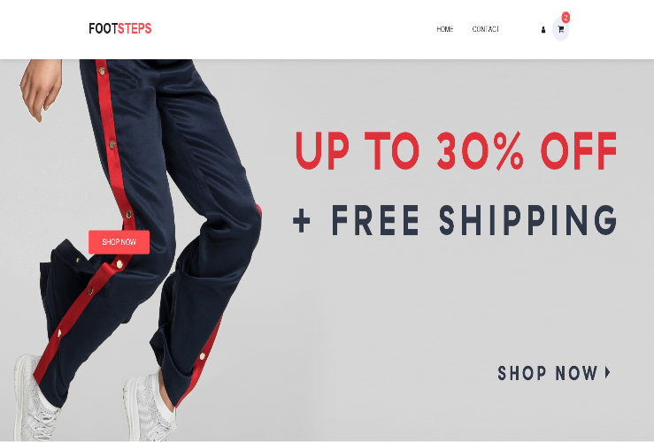 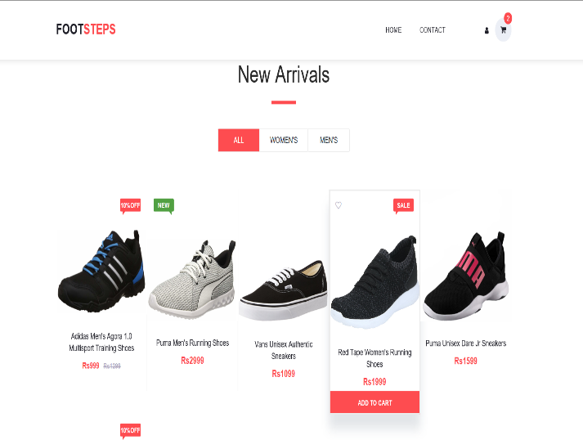

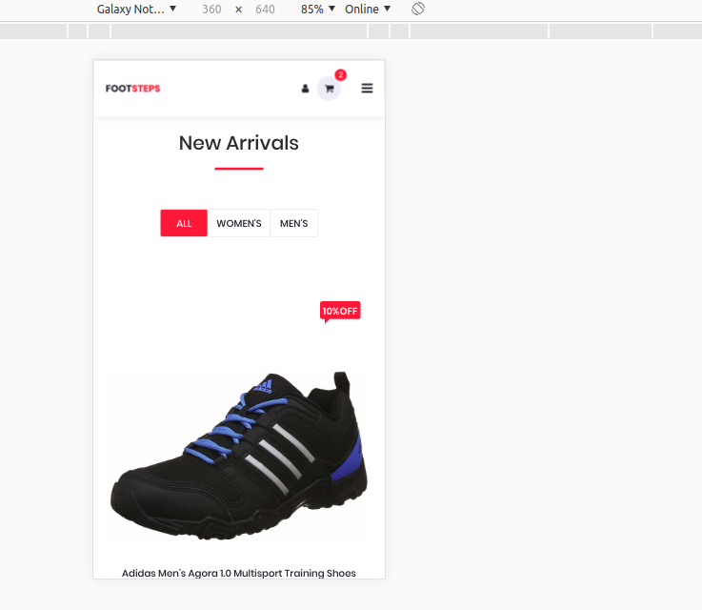 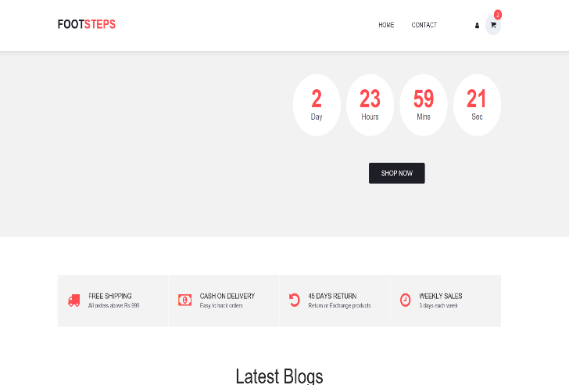

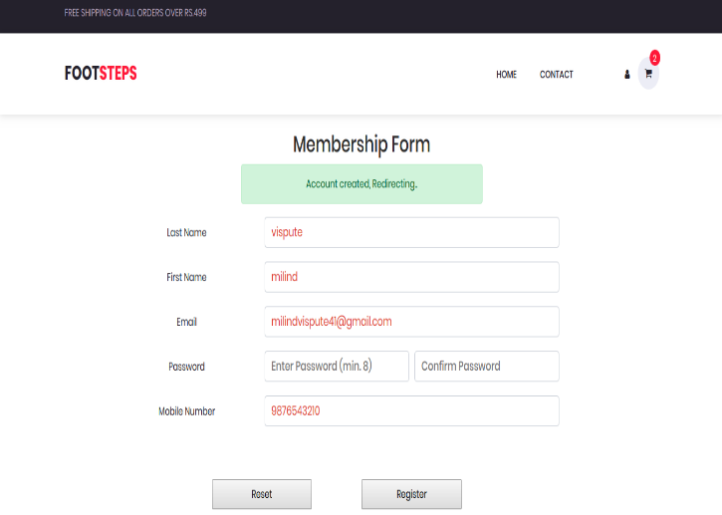 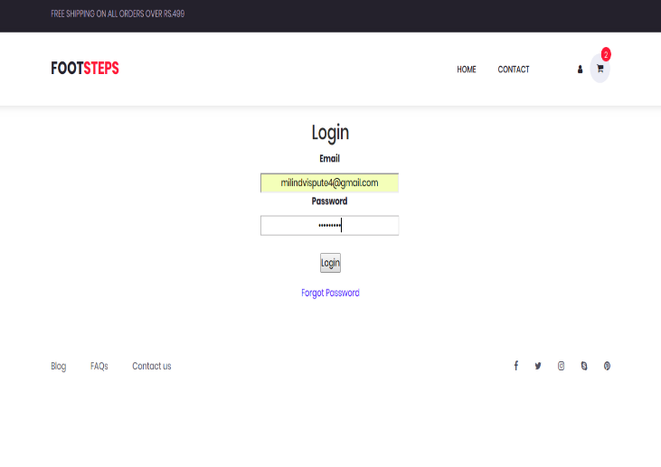

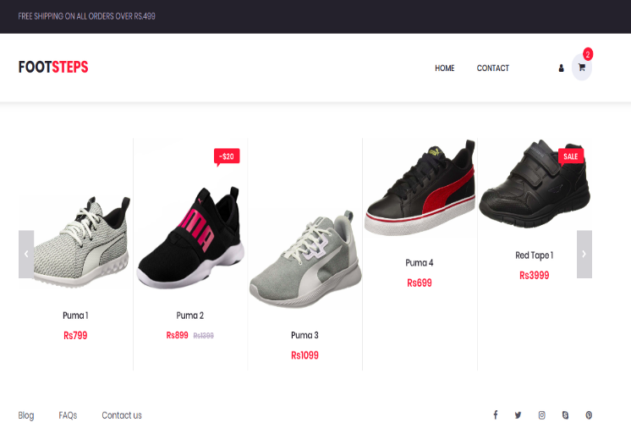 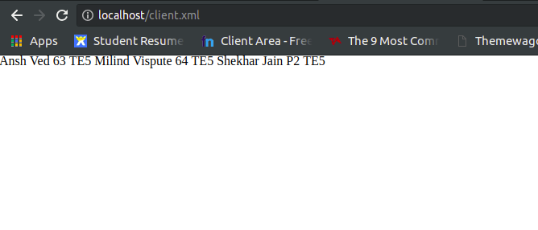

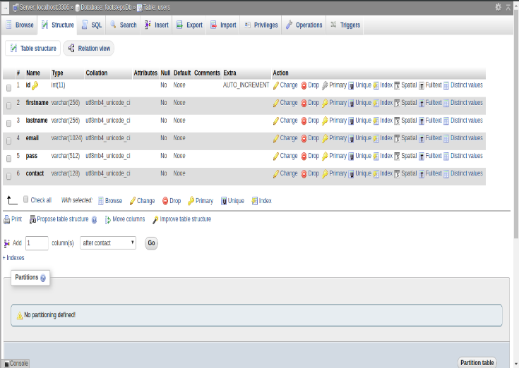 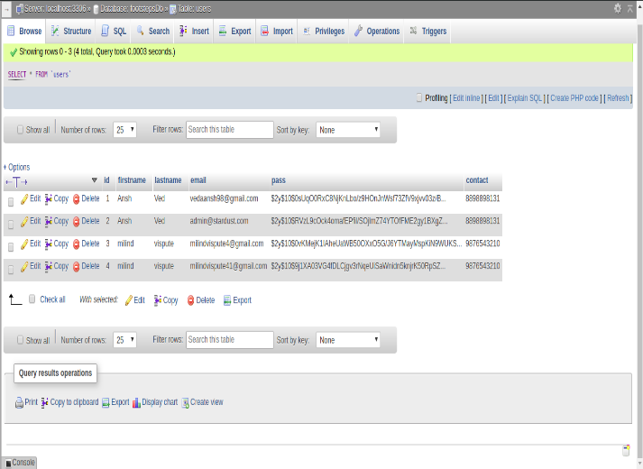

**CONCLUSION**

Through this project we took a step towards to minimize the gap between the students a faculty using a common interaction platform using php for discussion purpose. The present study contributes to the understanding of the effectiveness of online technical discussion forum in student improving their knowledge. here we provide the best way of learning the software paper like php c c++ etc. We extend the current topics of discussion that use of multiple environment and improve the learning facilities. Education discussion forum has positive effect on student interest and interaction also learning, when fill bore with the traditional classroom lecture. By applying this the future scope will also increase like distance learning and professionals of work.

**ACKNOWLEDGEMENT**

The work has successfully completed with the contribution of all the people. It gives me immense pleasure to give my heartily welcome to various people directly or indirectly related to my present project work. We sincerely believe that I was not enough to have come across a group of human whose mere mode of living can inspire someone to work. My project guide Prof. Ms. Swati Gajbhiye, Asst. Prof in Department of Information Technology Engineering. She not only encouraged me to pursue my work but also initiated the self-belief and confidences, which helps me to take on various trivial, serious and inevitable hassles of life.